**Advanced Programming Lab# 03**

**Submitted by: Daud Nasir Cheema (209563)**

**Task 1:**

<!DOCTYPE html>

<html>

<head>

<title>JavaScript &amp; jQuery - Chapter 7: Introducing jQuery - Event Object</title>

<link rel="stylesheet" href="css/c07.css" />

</head>

<body>

<div id="page">

<h1 id="header">List</h1>

<h2>Buy groceries</h2>

<ul>

<li id="one" class="hot"><em>fresh</em> figs</li>

<li id="two" class="hot">pine nuts</li>

<li id="three" class="hot">honey</li>

<li id="four">balsamic vinegar</li>

</ul>

</div>

<script src="js/jquery-1.11.0.js"></script>

<script>

sp = document.createElement("span");

sp.classList.add("date");

$("li").click(function(){

d = new Date();

if(sp.hasChildNodes())

sp.removeChild(sp.childNodes[0]);

sp.append("Clicked on " + d.toUTCString());

$(this).append(sp);

});

</script>

</body>

</html>

**Output:**

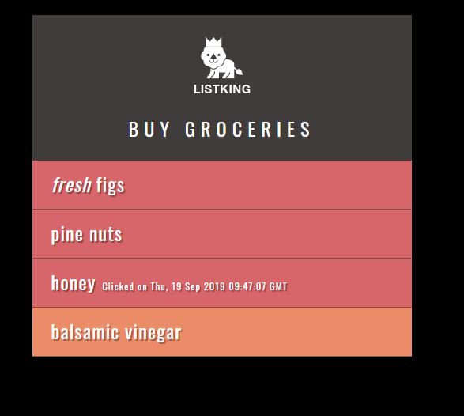

**Task 2:**

<!DOCTYPE html>

<html>

<head>

<title>JavaScript &amp; jQuery - Chapter 7: Introducing jQuery - Event Object</title>

<link rel="stylesheet" href="css/c07.css" />

</head>

<body>

<div id="page">

<h1 id="header">List</h1>

<h2>Buy groceries</h2>

<ul>

<li id="one" class="hot"><em>fresh</em> figs</li>

<li id="two" class="hot">pine nuts</li>

<li id="three" class="hot">honey</li>

<li id="four">balsamic vinegar</li>

</ul>

</div>

<script src="js/jquery-1.11.0.js"></script>

<script>

p = document.createElement("p");

p.append(document.createTextNode("Click or mouseover a hot item"));

$("#page").append(p);

$("li").click(handleEvent);

$("li").mouseover(handleEvent);

function handleEvent(){

$item = $(this).text();

console.log($(this).text())

str = "Item: "+$item+"<br />Status: ";

if($item == "honey" || $item == "pine nuts")

str += "Important<br />Event: " + event.type;

else

str += "Available<br />Event: " + event.type;

$("p").html(str);

}

</script>

</body>

</html>

**Output:**

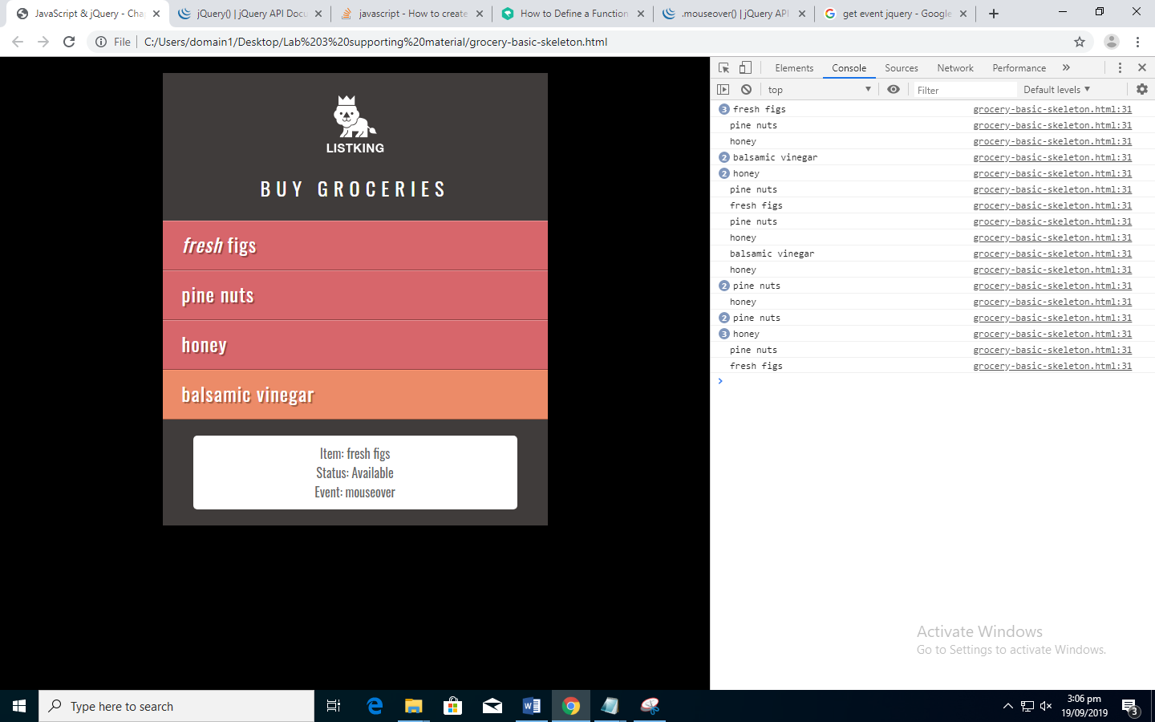

**Task 3** (changed #slideAd right to right:25px in css file)**:**

<!DOCTYPE html>

<html>

<head>

<title>JavaScript &amp; jQuery - Chapter 7: Introducing jQuery - Event Object</title>

<link rel="stylesheet" href="css/c07.css" />

</head>

<body>

<div id="page">

<h1 id="header">List</h1>

<h2>Buy groceries</h2>

<ul>

<li id="one" class="hot"><em>fresh</em> figs</li>

<li id="two" class="hot">pine nuts</li>

<li id="three" class="hot">honey</li>

<li id="four">balsamic vinegar</li>

<li>some item</li>

<li>some item</li>

<li>some item</li>

<li>some item</li>

<li>some item</li>

<li>some item</li>

<li>some item</li>

<li>some item</li>

<li>some item</li>

<li>some item</li>

<li>some item</li>

<li>some item</li>

<li>some item</li>

<li>some item</li>

<li>some item</li>

<li>some item</li>

<li>some item</li>

<li>some item</li>

<li>some item</li>

<li>some item</li>

<li>some item</li>

<li>some item</li>

<li>some item</li>

<li>some item</li>

<li>some item</li>

<li>some item</li>

<li>some item</li>

<li>some item</li>

<li>some item</li>

<li>some item</li>

<li>some item</li>

<li>some item</li>

<li>some item</li>

<li>some item</li>

<li>some item</li>

<li>some item</li>

<li>some item</li>

<li>some item</li>

<li>some item</li>

<li>some item</li>

<li>some item</li>

</ul>

<div id="footer" style="line-height:1in;">ListKing</div>

<div id="slideAd">Buy Listing Pro for $1.99 only!</div>

</div>

<script src="js/jquery-1.11.0.js"></script>

<script>

$("#slideAd").hide();

$(document).scroll(function(){

$h = $(document).scrollTop();

if(($('#footer').offset().top)-$h-690>0)

$("#slideAd").hide("slow");

else

$("#slideAd").show("slow");

});

</script>

</body>

</html>

**Output:**

